C:\Documents and Settings\arun.joy\Desktop\flag.png

|  |  |
| --- | --- |
| **Last Updated:** | Jan 18, 2018 |



|  |
| --- |
| **Web Registration** |
| **Quick Start Guide** |

# Introduction

Web Registration provides a friendly web user interface allowing users to register their organization's components and batches to a common database. Users can add, search, edit components and batches and share registration records over a network through a simple and user-friendly web interface. Any user can immediately track the records submitted by another user, enabling them to gather information stored in the database easily and quickly.

Users can enter data and administrators can manage the application configuration and settings. Registration is capable of detecting duplicate entries through a duplicate resolution mechanism before registering the component in the database.

# Web Registration Process

The registration process includes the following steps in order:

1. The **Submitter** (typically a chemist/biologist), enters chemical data into Web Registration. The data is stored in a temporary database. The submitter can search, edit, or delete the data as desired.
2. The **Reviewer** checks and approves records in the temporary table for registration. This is applied when "ApprovalsEnabled" is set to True in the Registration system settings.
3. The **Registrar** (typically a senior chemist or lab manager) reviews and registers submissions to the registry. The data is then stored permanently in the database.

# Logging In to Web Registration

In order to access the Web Registration, you need to have a user account created in advance in CBOE Manager.

**To log in to Web Registration:**

1. Open a web browser and paste the following URL: <http://Servername/Registration.Server/login>
2. The log in page appears. Enter your credentials and click **Sign in**.

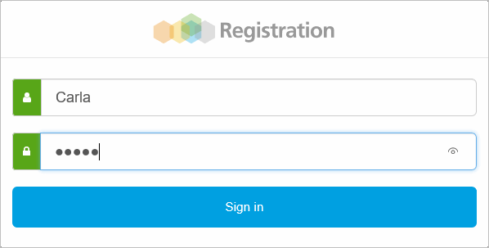

The **Temporary Registration Records** page displays:

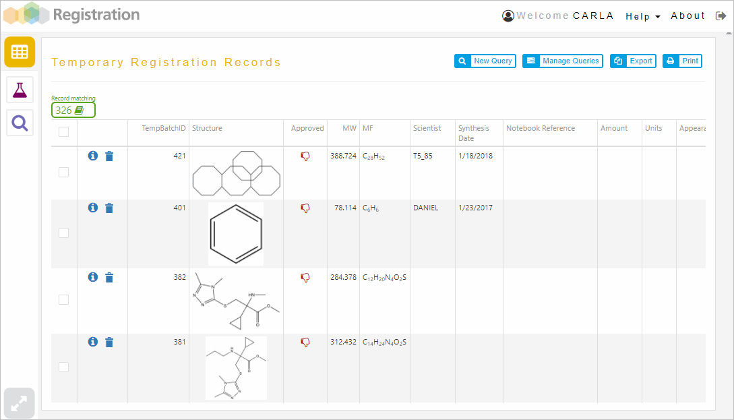

Select a record/multiple or all records in the list to mark it/them, to get and to execute the menu options that appear at the top of the table:

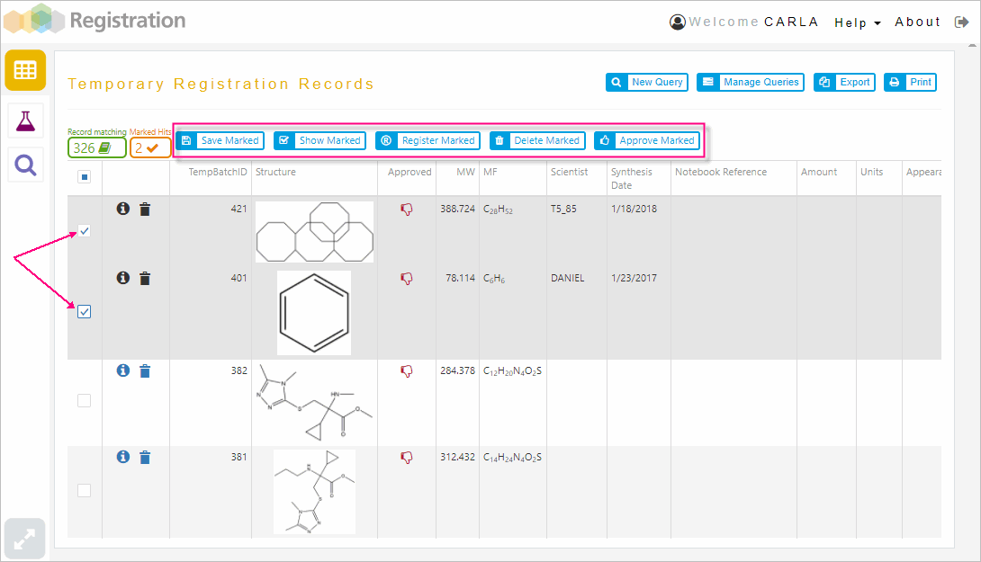

|  |  |
| --- | --- |
| **Option** | **Action** |
| Save Marked | To save the marked records as a new hit list |
| Show Marked | To display only the marked records in the list |
| Delete Marked | To delete the marked records in the list |
| Approve Marked | To approve the marked records in the list |

# Searching Temporary Registry

You can run searches to look for specific records in the list of temporary registered records.

**To run searches:**

1. Click on **New Query** button. The **Search Temporary Registry** page displays.

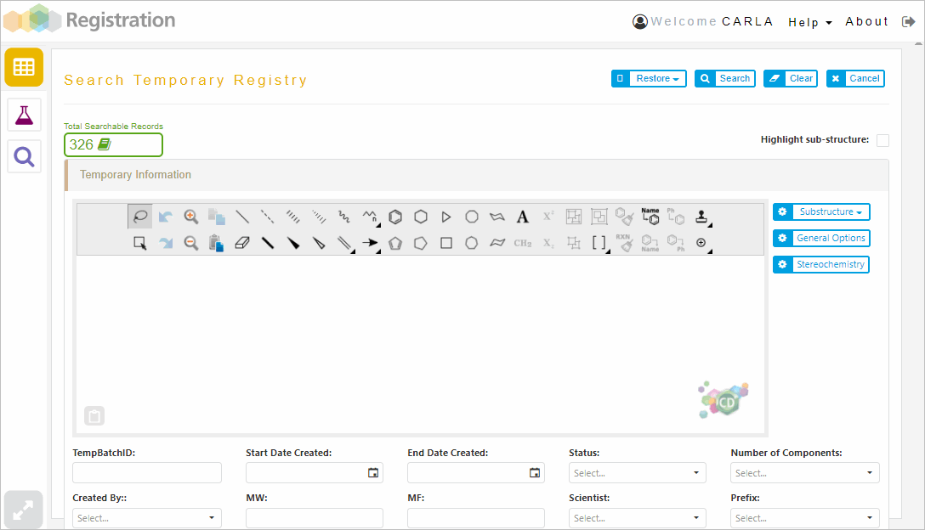

1. Enter the search criteria under **Temporary Information**. Using the ChemDraw Direct tools, draw in the drawing area the chemical structure that you are searching for and then click **Search**. A list of records matching the search criteria you specified appears.

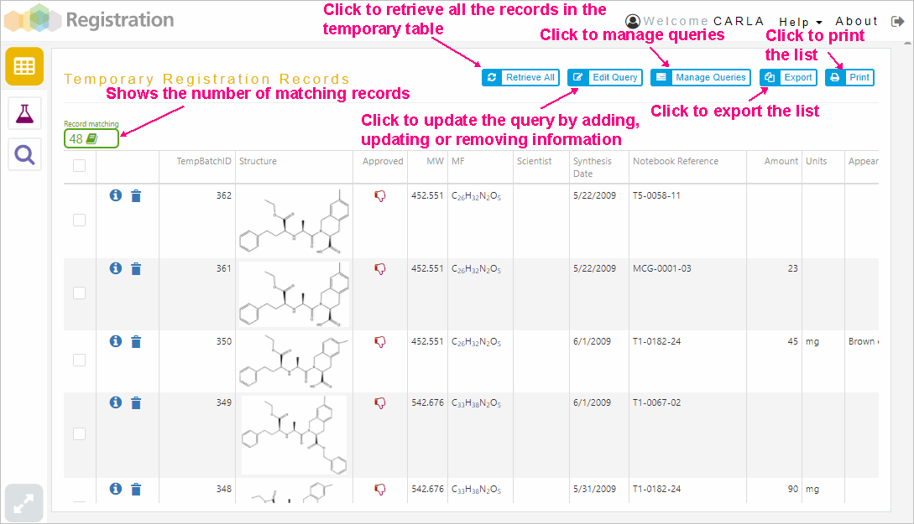

## Managing Queries

The criteria you enter in the query input form to perform a search (a drawn structure, molecular name, etc.) is collectively called a query. You can restore, save, and delete queries that you have used to search Registration.

To manage queries, click on **Manage Queries** button. The **Query Management** page displays:

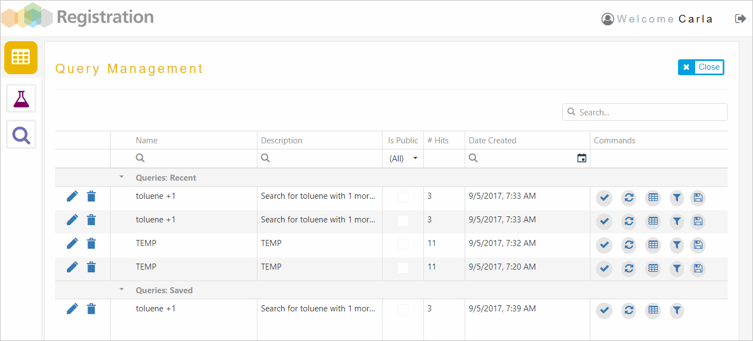

For every query there is a list of actions that you can perform:

|  |  |
| --- | --- |
| **Click on** | **Action** |
|  | To restore the hit list of the corresponding query that has been executed |
|  | To perform the corresponding query |
|  | To restore the query input into the search form |
|  | To integrate the results of a saved query with the results of the current query. Following are the options:   * Intersect with current list: displays only those records that appear in both the current hit list and in the saved hit list. This is a Boolean AND operation. * Union with current list: displays all records in either the current list or the saved hit list. This is a Boolean OR operation. * Subtract from current list: displays only those records that are in the saved hit list but are not in the current hit list. |
|  | To add the query to the saved hit lists |
|  | To edit the query name and description and make it public or not |
|  | To delete the query |

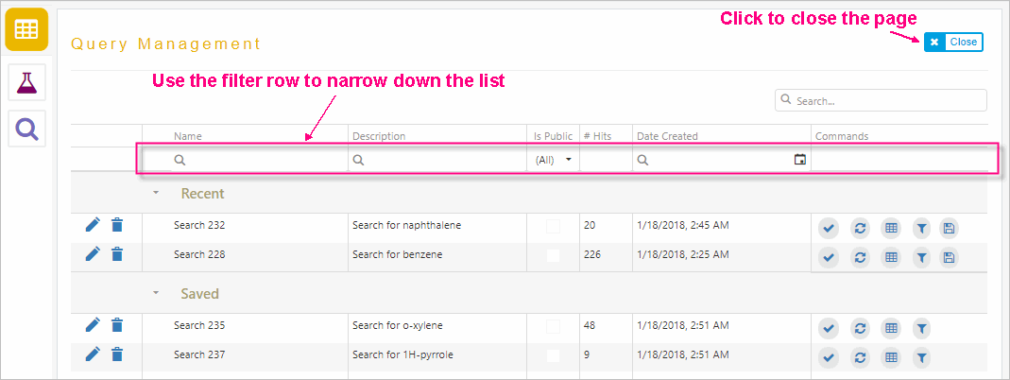

# Submitting New Compounds

You can submit a record to the temporary table in the database or, if you have adequate privileges, you can approve and register the record directly to the permanent table.

**To submit a compound to the temporary table:**

1. Click on **Submit New Compound** icon. The **Register a New Compound** page appears:

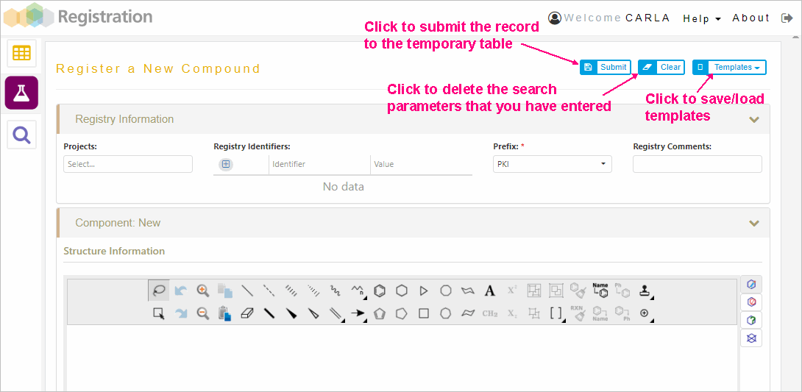

1. Enter the record’s details in the corresponding fields
2. Click **Submit** button to send the record to the temporary registry

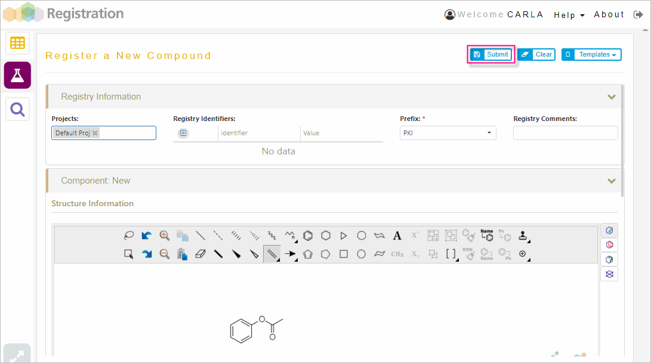

The record gets added to the **Temporary Registration Records** list:

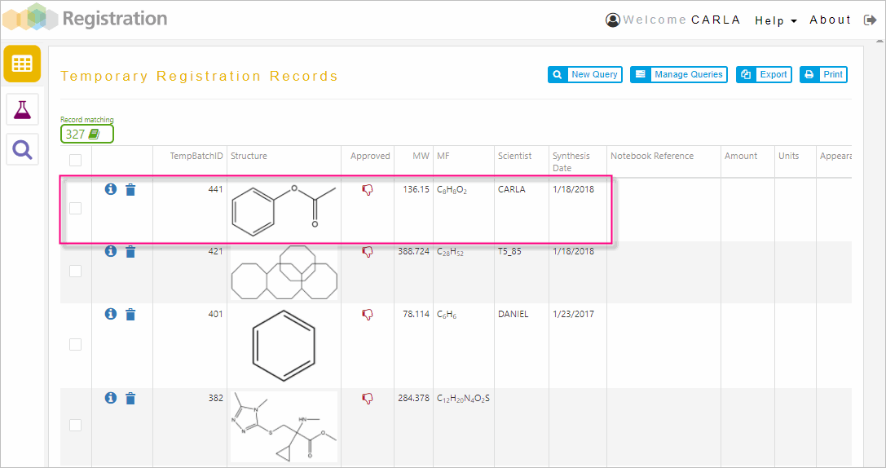

1. Log in to Web Registration with reviewer privileges and click on the **Detail view** icon, the record’s details display.
2. Click **Approve** button, to approve the record.

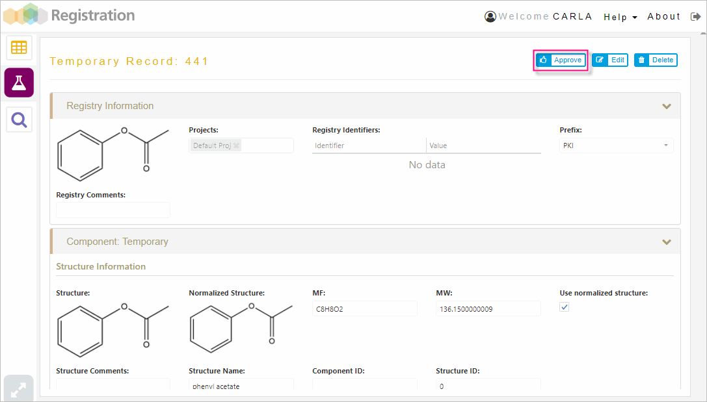

The record is ready to be registered.

1. As a registrar log in to Web Registration and look for the record to register by either running queries, using the search text box or using the filter row.
2. After you find the approved record to register, click on the **Detail view** icon and click on **Register** button

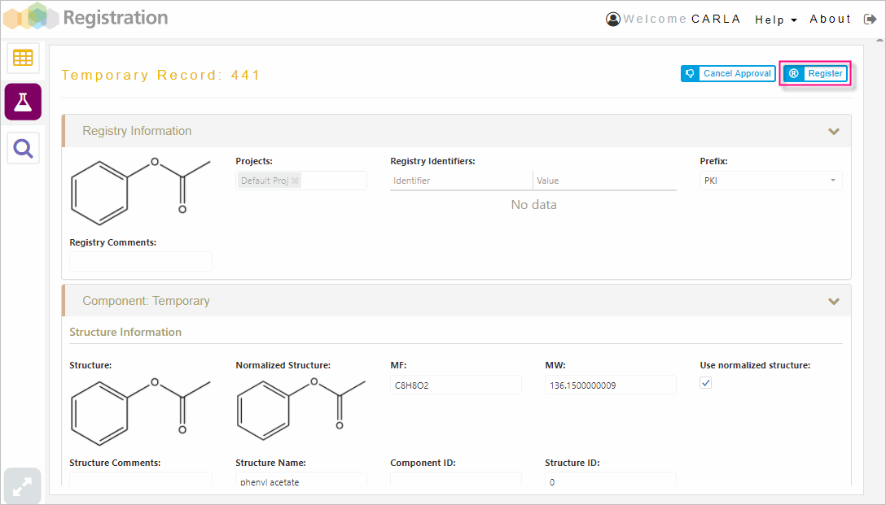

The record gets added to the **Registration Records** list:

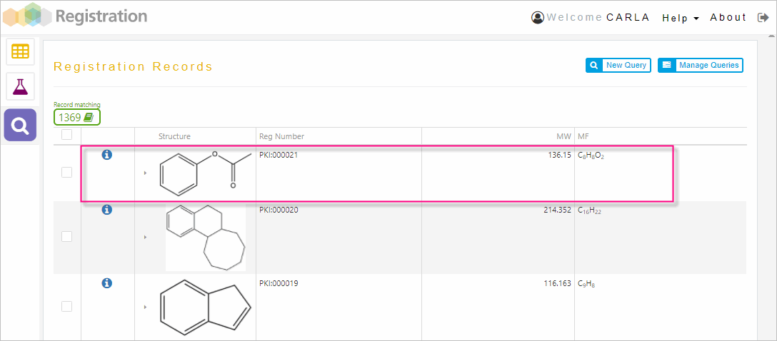

Note: The options that you see when you log in depend on the privileges that you are granted by the administrator user.

## Saving/Loading Templates

You can save a record as a draft for later use by selecting **Save as Template** option under **Templates** menu.

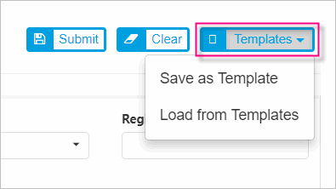

To open saved templates, click on **Load from Templates** option under **Templates** menu and select the template that you want from the available list.

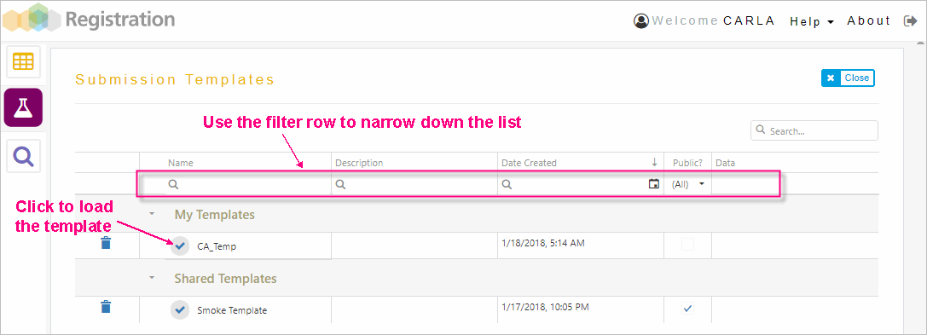

# Searching Registry

You can run searches to look for specific records in the list of permanent registered records.

**To run searches:**

1. Click on **Search Registry** icon, the **Registration Records** page displays

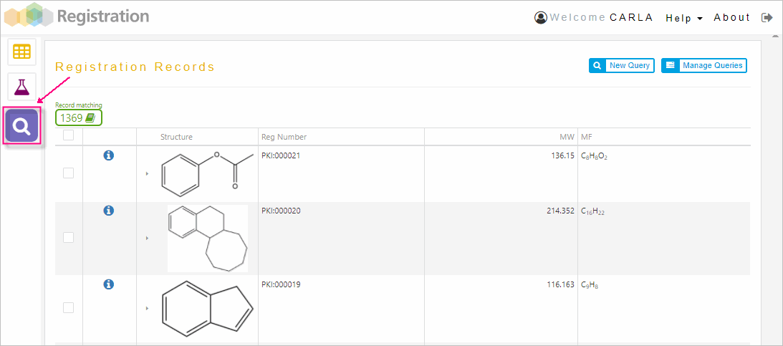

1. Click on **New Query** button, to open the **Search Permanent Registry** page

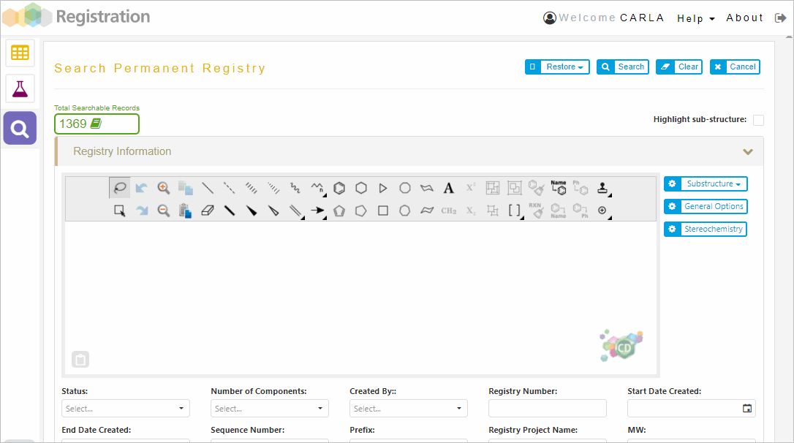

1. Enter the search criteria under **Registry Information**. Using the ChemDraw Direct tools, draw in the drawing area the chemical structure that you are searching for and then click **Search**. A list of records matching the search criteria you specified appears.

In the **Search Permanent Registry** page, click:

* **Clear** to delete the search criteria you entered
* **Cancel** to close the search form and move back to the permanent registered records in list view.

The Restore button lets you restore a query that has been previously executed:

The following options are possible:

* Restore Last Hitlist
* Perform Last Query
* Restore last Query to Form

As for the temporary registration records hit list, you can perform the following actions from the registration records hit list page:

* Retrieve all records
* Edit the current query
* Manage the queries
* Export the records
* Print the records

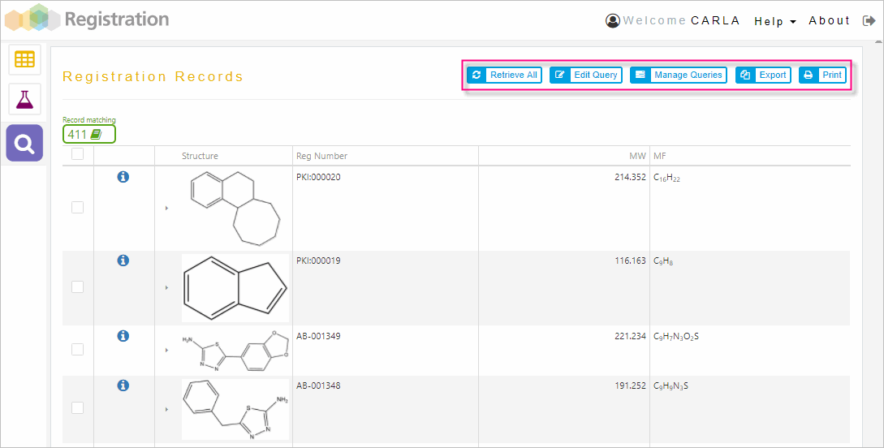

Use the filtering row to narrow down the list based on specific criteria you enter.

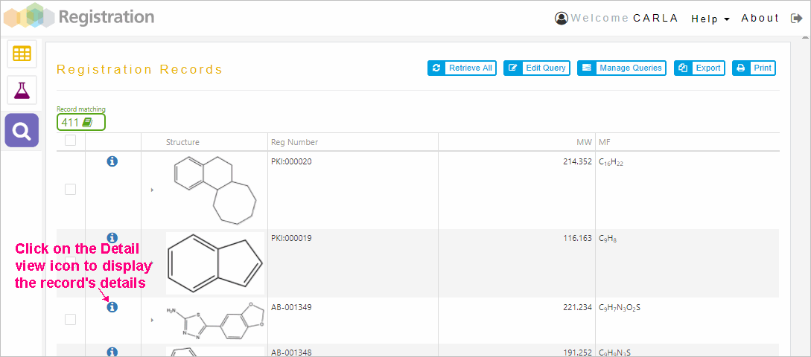

Clicking on the detail view icon for a particular record, the following page displays:

